Project Proposal

by Kamile Kavaliauskaite

Research Report

Submitted in partial fulfilment for the degree of
BSc (Hons) Computer Science

Supervised by Dr./Prof. Fuad Marwan



Heriot-Watt University
School of Mathematical and Computer Sciences

8th September 2025

The copyright in this dissertation is owned by the author. Any quotation from the dissertation or use of any of the information contained in it must acknowledge it as the source of the quotation or information.

Authorship Declaration

Course code and name | F20PA Research methods and Requirements engineering
Type of assessment | Individual
Coursework title | Project Proposal
Student name | Kamile Kavaliauskaite
Student ID | H00460022

By signing this form:

- I declare that the work I have submitted for individual assessment or the work I have contributed to a group assessment is entirely my own. I have not taken the ideas, writings or inventions of another person and used them as if they were my own. My submission or my contribution to a group submission is expressed in my own words. Any uses made within this work of the ideas, writings or inventions of others, or of any existing sources of information (books, journals, websites, etc.) are properly acknowledged and listed in the references and/or acknowledgements sections.
- I confirm that I have read, understood and followed the University’s Regulations on academic misconduct as published on the University’s website, and that I am aware of the penalties that I will face should I not adhere to the University Regulations.
- I confirm that I have read, understood and avoided the different types of plagiarism explained in the University guidance on Academic Integrity and Plagiarism.

Student signature: Kamile Kavaliauskaite

Date: 8th September 2025

Your work will not be marked if a signed copy of this form is not included with your submission.

Acknowledgements

I am thankful for my project supervisor Marwan Fuad for guidance and inspiring meetings. Also, I am thankful to my friends and partner for moral support during work on this project.

Abstract

Finding a phone number that appeals to the customer could be a challenging and time-consuming task. The number of available phone numbers could be overwhelmingly large. Furthermore, the concept of what is easy to remember can be quite subjective from customer to customer. Each person has their own combinations of numbers which carry certain personal meaning, like dates, lucky numbers. Because of these two problems, finding the optimal number could take a lot of time.

This project aims to develop a system that automates this process. It identifies and ranks numbers, which fall into a category of memorable by matching certain rules to the numbers available in a dataset. The rules represent certain numerical patterns such as repetition, sequences, symmetry, and palindromes.

This system uses a modular, multi-agent design where each rule functions as an independent agent that contributes to the overall memorability score computation. The Temporal Difference learning is used to incrementally adjust the weights of features in response to limited user feedback. This enables personalised number suggestions, which adapt to what each user considers memorable in the number.

Table of Contents

Authorship Declaration ii
Acknowledgements iii
Abstract iv
Table of Contents v
1 Introduction 1
1.1 Background and Motivation 1
1.2 Aim and Objectives 2
1.3 Organisation 2
2Background Research 2
2.1 Human memory and numeric patterns 2
2.2Algorithms 3
2.2.4 Modular multi-agent learning 5
3 Methodology and work plan 6
3.1 System workflow 6
3.2 Methods 7
3.3 Ranking rules and scoring 7
3.4 Requirements 8
3.4.1 Functional requirements 8
3.4.2 Non-functional requirements 9
3.5 Research goals 9
3.6 Research methods 10
3.7 Stakeholders and use cases 10
3.8 Tasks 10
3.9 Evaluation strategy 10
4Feasibility 11
4.1 Technical feasibility 11
4.2 Resource and time feasibility 11
4.3 Stakeholders and use cases 12
4.4 Scalability 12
5 Conclusions 12
Motivation and goals 12
Proposed work 13
References 14
A. Project Management 15
A.1. Gantt Chart 15
A.2. Risk Analysis 16
A.3. Ples 17
B. Generative AI 17
A.4 Rules 17
A.5 UML activity diagram 18
A.7 Project management 18

- Introduction

Automating small tasks that can be time-consuming is a smart decision for any business, would be a cost-effective solution. A distinctive phone number is not only useful for a regular client, making it easier to remember but also for a business to be recognisable and look more professional. However, the process of identifying an ideal number manually is a complex task. Each new number that is picked by a customer can be unique, depending on their personal preferences and needs, making it challenging to select the optimal choice.

Certain numerical patterns can be classed as easy to remember. They tend to adhere to simple rules, such as symmetry, repetition, and sequences. Number combinations such as 50505050 or 123321 stand out from other types of patterns, for example, 481632 (geometric sequence). That is why it is important to implement a ranking system that ensures that selections are optimal.

This project proposes a rule-based modular system that has predetermined rules, which act as independent micro-agents. The combination of agents evaluates appearing patterns in the numbers structure and contributes to the overall ranking score, which serves as the numbers' overall evaluation of how memorable the combination is. With temporal differences learning, the system updates the weight of each rule based on user feedback. This design allows the system to be responsive to each user's preferences using dynamic reinforcement.

  - Background and Motivation

The motivation for this project is to develop a system that businesses can use to optimise their daily tasks, making it more profitable and time-saving. The purpose of recognising memorable phone numbers for a business can be influential to advertising and brand consistency. Similarly, individual customers often prefer numbers that are easier to remember or have significant personal value, including certain combinations of numbers resembling important dates, lucky, or angel number formations. Choosing the optimal number from a vast dataset of available ones can be an impossible task without the help of such an automated system.

This project is using principles of pattern recognition, reinforcement learning and cognitive psychology. It is designed in a way with multi-agent modularity, so that each rule acts as a separate process. The temporal difference learning provides adaptability to the system and enables the system to update its logic of what is memorable according to the user, with limited feedback. It estimates the temporal difference error, distinguishing the expected and actual user preferences.

  - Aim and Objectives

The aim of this project is to design a system that is capable of identifying and ranking interesting phone numbers from a dataset of available options.

The objectives of this project to achieve this aim are listed below.

1. | Define rules that make numbers memorable to each user based on patterns such as symmetry, repetition, sequence, and implement them as independent agents.
2. | Implement Manhattan distance and cosine similarity algorithms for pattern detection and comparison.
3. | Develop a re-ranking multi-agent system where each agent contributes to an overall memorability score using temporal difference learning on user feedback.
4. | Provide a user interface that generates phone number suggestions and allows input as an example for further suggestions of available numbers.
  - Organisation

This document is structured into six main sections to define the problem and main objectives, a review of the research methodology required for the completion of the system.

Section one defines the motivation, aims and objectives for the creation of such a system, followed by section 2, which is the part where research analysis has been done. The first part of this section is cognitive research for defining what is memorable, what the preferences are to refine the vague term of memorability, and to make an educated decision about the rule ranking. Part two of this section overviews certain system design method choices backed up by rational cited from reputable sources. Section 3 dives deeper into how the researched methods will work together in a system workflow, methods, and requirements, research methods, tasks, evaluation strategy. Also, project stakeholders and use cases are overviewed in this section. Next Section 4 is dedicated to project feasibility. It confirms that from technical, resource and time perspectives, the project is feasible. Lastly, section 5 includes conclusions about this project.

2Background Research
The research that is required for this project consists of numeric patterns that are proven to be memorable, artificial intelligence, and data science concepts, which potentially can be used in the systems development.

2.1 Human memory and numeric patterns

It is important to define the specific patterns that are proven to be more memorable to people. Also, not every pattern is equally appealing, which raises the problem of the hierarchy of patterns. The decisions on ranking the patterns by their memorability.

The article on memory of numeric security codes of Martin Ramussen and Floyd W Rudmin shows that few of the top strategies for remembering the number sequences are “The next most common mnemonic strategy, reported by 54%, was to remember the pattern the code makes when entered on the keypad. The strategy of using security codes from other contexts was reported by 40%, and choosing a code with a personal meaning was reported by 38%” (Rasmussen and Rudmin, 2010). This is quite an important observation for this project, considering what strategies people use to make it easier to remember number sequences. These results suggest that 54% of their study participants tend to rely on the visual placement of the number sequence in the keypad. Some easy-to-remember sequences following such a strategy could be straight line patterns such as 123, 963, 357. Also, personal meaning is an extremely helpful strategy for recalling numerical patterns, which emphasises the need for user input and choice functionality in the system. Furthermore, it shows that participants relied more on contextual cues rather than randomness.

An article written by Cowan. N and Hardman. K. O. shows that “trains were generally helpful to recall, especially when they fell within a triad but to some extent even when they crossed triad boundaries” (Cowan and Hardman, 2021, p, 744). It supports the rule about repeated number sequences being a top priority when it comes to numerical pattern recalls. Another observation has been done on the repetition of numbers, which indicated high memorability. “There was some evidence that lists with 4 unique digits produced better recall than lists with less repetition and therefore more unique digits” (Cowan and Hardman, 2021, p. 752). It indicates that the least amount of unique numbers improves memorability. Also, this study shows how grouping can emphasises certain numerical patterns, leading to quicker evaluation of appealing combinations.

Furthermore, the Jones, Mari Riess, and June J. Baird's article explores the recall of three numerical patterns, such as symmetrical patterns, arithmetic sequences, and random patterns. “In general, it appears that symmetrical patterns are indeed simpler than patterns with other types of structure… In both serial and free recall modes, sequences with higher-order nominal redundancies were more accurately reconstructed than ones with arithmetic rules or lower-order structure alone” (Jones and Baird, 1979, p. 640). The findings show that symmetrical patterns take the first place as memorable patterns, followed by simple sequences.

2.2Algorithms

To optimise the best number picking ranking system after the user gives inputs and feedback, it can become a complex task when thinking about multiple rules and their intersections with each other. To make the number pick personalised for each user, the system should take into consideration what the user actually accepts as a memorable number.

2.2.1 Distance metrics

Distance metrics that could be used for the development of this system are cosine similarity and Manhattan distance. These metrics can detect how similar two numeric patterns are. Each of them has a distinct use in the system.

The Manhattan distance is used for measuring the total absolute difference between two features using vectors. As a distance metric type, it is capable of detecting the two numbers with the least amount of change. Levy, A., Shalom, B.R., and Chalamish, M state in their article that gives a good example of how Manhattan distance can be used to compare numerical patterns. “dL1 ((5, 3, 4),(2, 5, 7))= 8” (Levy, Shalom and Chalamish, 2025). It finds and sums the difference of each number, giving a possible score that determines how similar two numbers are by comparing their digits.

The cosine is a similarity vector-based type of metric. It detects numerical patterns that are similar. It compares the angle of two vectors to detect similarity. As Levy, A., Shalom, B.R., and Chalamish, M state in their article “Cosine similarity is scale invariant, hence, useful for applications where the relative size of a vector is not important.” (Levy, Shalom and Chalamish, 2025) In this case, cosine similarity captures the numerical patterns even if they differ in specific numbers.

2.2.2 Rule-based weighted ranking system

In this project, the memorability of a number is calculated using a positional scoring rule, which is a weighted combination of features. The score needs to represent how many digits the pattern occupies; it is the level of compliance with the specific type of pattern. The overall memorability score is computed as the weighted combination of features.

Because the memorability concept is subjective, there is a level of uncertainty in making a decision on the optimal weight for each rule. This creates a risk of inadequate suggestions, especially taking into consideration the personal preferences. The related concept is explored in Viappiani “Robust winner determination in positional scoring rules with uncertain weights”. The article recognizes the main reason behind the need for a proper weight system. “Setting the weights associated with rank positions is a crucial task, as different instantiations of the weights can often lead to different winners” (Viappiani, 2020). While Viappiani suggests a minimax regret to manage weight uncertainty, which could be a valuable optimisation for picking the numbers in a personalised manner. Although, because of limited time resources, the initial project will have a simpler and more lightweight method – temporal difference learning. The system will iteratively optimise the memorability score by incrementally adjusting the weight.

2.2.3 Temporal-Difference learning

Due to the limited user feedback for diagnosing the preference, the system must rapidly learn from sparse user feedback. The user will probably make from 3 to 5 asks for new, different number recommendations, before just picking the most appealing one. The more users interact with the system, the easier it is for the system to tailor suggestions, adhering to the users’ preference logic. To make the system optimal, the learning functionality must be quick to adapt. For that reason, the learning method to be used for this type of system must be model-free to make adaptive weight adjustments without predefined assumptions of user actions.

In the Sutton and Barto book “Reinforcement learning: an introduction,” it is defined as “TD learning is a combination of Monte Carlo ideas and dynamic programming (DP) ideas. Like Monte Carlo methods, TD methods can learn directly from raw experience without a model of the environment’s dynamics. Like DP, TD methods update estimates based in part on other learned estimates, without waiting for a final outcome” (Sutton and Barto, 1998, p. 120). This combination is perfect for this project because it allows each user’s choice to be treated as a learning event. This way, the system is dynamically reinforcing its decision on what the memorable number is. Such a system is delivering more accurate personalised recommendations with each user's choice.

2.2.4 Modular multi-agent learning

The system's modular design allows for treating each rule as a separate agent, maintaining its own weight and TD updates. Learning utility-based agents collectively determine the overall memorability score by their independent contributions, which are based on individual rules.

This type of structure, where multiple agents collaborate towards a common goal, is similar to Kurt-Nelson and Redish's proposed multi-agent architecture. “Each µAgent maintains an independent hypothesis about the state of the world, and a separate value-estimate of taking actions within that hypothesized state. The overall agent thus instantiates a flexible representation of an evolving world-state” (Kurt-Nelson and Redish, 2009, p. 3). This way system achieves modularity, each improves the ranking system logic in comparison to a singular agent for making an overall estimation on the possible weight updates rather than a single global model.

Furthermore, this structure aligns with the multi-agent architecture proposed by Russell and Norvig “Cooperative game theory considers settings in which agents can make binding agreements to form coalitions in order to cooperate. Solution concepts in cooperative game attempt to formulate which coalitions are stable (the core) and how to fairly divide the value that a coalition obtains (the Shapley value).” (by Russell and Norvig, 2021) All the agent contributions, and their differently weighted combination, make the final memorability score.

When personal preferences of what is memorable are considered, the temporal difference learning process enables the adjustment of the rule hierarchy by incrementally adjusting the weights. This makes the system highly responsive and personalised.

- Methodology and work plan

In this section the workplan for this project is outlined and explanation how the researched methods will be used within the system.

3.1 System workflow

The system is designed as a modular workflow and consists of atomic operations. Each operation has a specific ranking and pattern-recognition task. To start with, the system must load the available phone numbers from a given dataset and calculate a memorability score. The system will calculate the scores for each available phone number using a weighted combination of the defined memorability rules, such as symmetry, repetition, sequences, keyboard patterns, and unique digit count. This way, the user gets the first 5 suggestions of phone numbers with the very best rank.
The user then has three options.
            - Select one of the five suggested phone numbers as theirs.
            - Request similar numbers to one of the five suggested numbers as an example combination. In this case, the cosine similarity method is applied to find similar number patterns.
            - Input a sequence of numbers with a desirable pattern.

In case the user decides to input their own sequence of numbers, as a priority, the system must try to find an exact match of the pattern present in the available numbers dataset using string comparison. If the exact match does not exist containing the sequence, then the system uses Manhattan distance to determine the closest distance between the suggested and available numbers. Finally, the system makes use of the memorability score to make sure that the number is not only the best match to the user's input but also is one of the highest scoring suggestions for the memorability score, applying weighted ranking.

With each user interaction, the system gradually adjusts the weights using Temporal Difference learning to improve the personalised suggestions. The TD error will be calculated to determine how much the expected and observed memorability score differ. Then the TD error will be used by micro agents in the calculation of individual weight updates. The agent takes into consideration of how much the rule contributed to the number set by the score of that feature. Finally, the system combines agents' calculations to make a new personalised memorability score and gives the user the best ranking number.

3.2 Methods

To achieve the objectives, the following methods will be used: pattern recognition, rule-based ranking, similarity search, modularity, multi-agent system, and temporal difference learning.

Each rule is an atomic operation that analyses one aspect of the phone number structure, adhering to a modular design. This will ensure an easier testing procedure and data integrity. The rules check the symmetry, repetition, sequences, keyboard patterns, and unique digit count. Each outcome is normalised to a number from 0 to 1 for compatibility. Then the features are combined using a weighted score. This will produce the estimate for a memorability final score for a phone number.

Two distance metrics are going to be used for finding similar phone numbers. The Manhattan distance metric is going to find the number that is the closest match numerically, and the Cosine similarity metric will find the most structurally similar phone numbers.

The ranking mechanism in this system will use temporal difference learning to incrementally adjust the weights for each of the rules, making the suggestions more personalised. Because each rule acts as a separate meta or micro agent, the weight adjustments will be calculated independently and combined by the system into an overall adjusted memorability score.

3.3 Ranking rules and scoring

To rank the numbers as memorable, as mentioned in previous sections, it is important to distinguish the exact rules and hierarchy. At the beginning, the system will not have the users' preferences for what is memorable to them, which is why the ranking is important. Further in the process of picking the phone number, users' picks will implement the system's decisions of what is memorable in this specific case.

The exact rules are provided below, which are going to be used for initiating the ranking. They are organised in order of their memorability, based on the cognitive research findings mentioned in the research section. Taking into consideration that the cognitive studies analysed in the research section for number combination memorability are not a single study with further defined rules ranked systematically against each other, there is no initial hierarchy of the rules. Memorability may be quite subjective, so initial suggestions are not assumed to be the most appealing ones for the user. The user's choices will implement the system to find the most memorable case by comparison and weight. The final score will be a combination of preset logic rules and model user preferences. Each user interaction will feed further model learning.

Features will be normalised for compatibility to scale from 0 to 1. The rule about simple keyboard patterns matches exact numeric combinations and can match a maximum of 2 because of the phone number digit amount. To normalise this outcome, 0 will represent no matches, 0.5 will represent one match, and 1 will represent two matching number combinations to the phone number.

3.4 Requirements

The Requirements for this system are written using the Mosco method. They are ordered into the requirements that must be implemented; otherwise, the system would not be developed to the point where the main objectives could be tested. The requirements ranked as should have defined extra functionalities that such a system would benefit from. The requirements with could have ranking defines the requirements which may be implemented if there is enough time. The requirements ranked as won’t are mentioned only for the future development of the project but will not going to be implemented at this stage of the project development.

3.4.1 Functional requirements
FR 1 | The system must load a dataset of available phone numbers.
FR 2 | The system must detect numerical patterns based on predetermined rules.
FR 3 | The system must calculate a memorability score for each phone number.
FR 4 | The system must display suggested phone numbers with a high memorability rank to the user.
FR 5 | The system must enable the user to select one of the suggested phone numbers.
FR 6 | The system must allow the user to input desired numeric patterns.
FR 7 | The system must allow the user to get more similar suggestions to previously suggested phone numbers.
FR 8 | The system must update the ranking weights dynamically based on user feedback using temporal difference learning.
FR 9 | The system must manage modular rule components, which calculate weight updates that contribute to overall memorability score.
FR 10 | The system should store previous users' choices and inputs.
FR 11 | The system should be able to adjust its ranking depending on saved user choices.
FR 12 | The system could provide explanations for the ranking decisions.
FR 13 | The system could accommodate car number plates.
FR 14 | The system will not work on the external dataset integration.
FR 15 | The system will not support user authentication.

3.4.2 Non-functional requirements
NFR1 | The system must use distance metrics and complete it in under 1 second per query.
NFR 2 | The system must be able to read at least 1000 phone numbers from a dataset.
NRF 3 | The system must be able to rank at least 1000 phone numbers in under 5 seconds.
NFR 4 | The system must show adequate suggestions, clearly adhering to memorability rules.
NFR 5 | The system must complete temporal difference learning updates under 1 second after user feedback.
NRF 6 | The system should be able to work with larger datasets, for example 10 000 phone numbers, performing under 10 seconds.
NRF 7 | The system should provide error messages.
NRF 8 | The system could allow the user to select a preference for which rule of memorability adheres the most.
NRF 9 | The system could show the rationality analysis of why the numbers were selected and suggest to the user.
NRF 10 | The system won’t collect any personal data.
NRF 11 | The system won't have a mobile version application.

3.5 Research goals

The research aims to answer the following questions.

Which numeric patterns are most memorable to users? (Ob1)
Which distance metrics are most applicable for finding similarity between numeric patterns? (Ob2)
Can a rule-based weighted system using the TD learning method create a reliable and adaptive memorability ranking? (OB3)

3.6 Research methods

For the research, which was needed for this project, the Heriot-Watt University Discovery website was used. Only the sources that support the method decision was used. The deductive reasoning method was used with a top-down approach. After defining the main deliverables of the system, such as learning from user data, finding similarity, and defining the memorability, I have started narrowing down by methods that are not applicable for this project or do not align with the predefined workflow.

3.7 Stakeholders and use cases

This system's main stakeholder is the telecommunications business. A system as such would automate the process of picking the phone numbers, optimising the finding of the most distinctive, appealing, and memorable phone number for the user. The use case for this type of system could be in the shop while working with clients in real-time, also integrated into an online application for ordering a new phone number online, making the process more accessible to the user.

3.8 Tasks

This project is following Agile methodology, which perfectly aligns with the systems modular design. Iterative implementation and testing align well with this methodology, so each task can be set as a 1 or 2 week sprint. Here are the main tasks.

Implementation of memorability rules as micro-agents. (Week 1-2)
Implementation for similarity metrics. (Week 3-4)
Implementation of TD learning algorithm. (Week 5-6)
User interface development. (Week 7)
Testing. (Week 8)
Evaluation. (Week 9)

3.9 Evaluation strategy

The project evaluation will consist of two parts: computational evaluation and adaptability validation.

In computational evaluation, the main focus will be the non-Functional requirements and efficiency. The system will be tested against bigger datasets including 10000 phone numbers. This is needed to verify that the system can cope with large amounts of data and will perform well in real life conditions. Also, distance metrics will be tested for their performance, to ensure that they provide adequate suggestions and are useful part of the overall system.

The adaptability evaluation focus ensures that td learning mechanism work effectively. The systems calculated and recalculated weights will be tracked to extract the readings and ensure, that it works as expected. Similarly, the overall score will be recorded as well, and compared to previous readings to make sure, that the td learning mechanism works as expected.

This section outlined the project plan and system workflow, evaluation strategy. The feasibility is given in the next section 4.

4Feasibility

This section presents the technical and resources feasibility. The system design aims to be lightweight. The modularity enables the scalability and diversion to different kind of system with minimal loss of changes and resources. This project is achievable within the given time scale.

4.1 Technical feasibility

The system design is technically feasible. The system will be built using the Python language, making use of libraries such as Pandas, NumPy. The ranking system is designed in a lightweight way, using micro-agents, which will allow the system to rank and compare a large number of phone numbers in real time. The system is using a modular architecture, keeping data integrity, enabling optimal testing and scalability.

The temporal difference learning algorithm ensures that the system is responsive to users' preferences without requiring excessive feedback. Each micro-agent contributes to the overall memorability score. The system is model-free, although it still improves over time. This approach ensures that the system is lightweight.

Other methods that are required for such system are distance metrics, which are elegant and straightforward implementation.

4.2 Resource and time feasibility

This project will use open-source software and a synthetic dataset; therefore, it will be cost-effective. The personal computer will be used to create the system. The modular design aligns with the semester timeline, with the separate agent’s implementation gradually. See the Gantt chart in section A1 Gantt chart. For that reason, the Agile methodology optimises the development process.

4.3 Stakeholders and use cases

This system's main stakeholder is the telecommunications business. A system as such would automate the process of picking the phone numbers, optimising the finding of the most distinctive, appealing, and memorable phone number for the user. The use case for this type of system could be in the shop while working with clients in real-time, also integrated into an online application for ordering a new phone number online, making the process more accessible to the user.

4.4 Scalability

This system may be scaled to also pick interesting or memorable car number plates. Minimal adjustments would have to be made to handle alphabetic data and its structures. The rules defined in the section above may also apply to number plates. Additional rules for processing the homoglyphs would be needed and the use of a short word dictionary to match letter combinations to meaningful words.

Because of the system's modular design, the implementation of such new rules as additional agents would be feasible in a short amount of time and with minimal adjustments.

This section proved, that the proposed system is not only feasible, but also scalable, due to the modular lightweight design. See conclusions in the next section 6.

5 Conclusions
This section is dedicated for conclusions of the project analysis. The first part of conclusions – motivation and goals define why such system is useful. An the section Proposed work aims to overview the overall project and possibility for scalability.

Motivation and goals

This project proposal is an overview of the development of the system that automates the process of finding an easy-to-remember phone number, taking into account users' cognitive preferences, by implementing appropriate computational algorithms. The aim is to help businesses automate a mundane task and produce personalized recommendations.
The main goals for this project are:
Creating a system, which identifies the most memorable for each user numberical patterns (RG1).
Determining the importance of distance metrics for similarity search (RG2).
Confirming that rule-based TG learning system can be a reliable solution for such project (RG3).

Proposed work
This system uses a rule-based scoring system with weights, similarity measures, and adaptive learning methods.
The research that has been done to design this type of system architecture reviewed the cognitive human preference for what is considered a memorable number combination. This influenced the process of defining the exact rules that represent numerical patterns. For a system to be adaptive to users' unique preferences, the temporal difference learning will be implemented in the system. This enables weight adjustment of memorability rules in real time on sparce user feedback.
The design of the project is feasible within the project's timeline and available resources. The Agile methodology used for project planning and management ensures that modular components can be implemented, improved, and tested independently. The Agile methodology ensures that the development process is iterative, enabling efficient development and new functionality integration.
In addition, this project is structured with consideration of future scalability. The modular systems design could be upgraded to similar systems, such as car number plate suggestions, with minimal changes.
In conclusion, this project combines cognitive research, and adaptive reinforcement learning to develop a system which is feasible, lightweight, and optimal.

References
- Cowan, N. and Hardman, K.O. (2021) Immediate recall of serial numbers with or without multiple item repetitions, Memory (Hove), 29(6), pp. 744–761. Available at: https://doi.org/10.1080/09658211.2021.1942920 (Accessed: 09/11/2025)
- Jones, M. R, and Baird J. J. (1979) Memory for Symmetry: Real or Artifact, The American Journal of Psychology, vol. 92, no. 4, pp. 627–51. Available at: https://doi.org/10.2307/1421793 (Accessed 09/11/2025)
- Kurth-Nelson, Z. and Redish, A.D. (2009) ‘Temporal-Difference Reinforcement Learning with Distributed Representations’, Plows one, 4(10), pp. e7362–e7362. Available at: https://doi.org/10.1371/journal.pone.0007362 (Accessed: 11/11/2025)
- Levy, A., Shalom, B.R. and Chalamish, M. (2025) A guide to similarity measures and their data science applications, Journal of Big Data, 12(1), pp. 188–57. Available at: https://doi.org/10.1186/s40537-025-01227-1 (Accessed: 09/11/2025)
- Rasmussen, M. and Rudmin, F. W. 2010. The coming PIN code epidemic: A survey study of memory of numeric security codes. Available at: https://munin.uit.no/bitstream/handle/10037/3031/article.pdf?isAllowed=y&sequence=1 (Accessed: 09/11/2025)
- Russell, S, & Norvig, P 2016, Artificial Intelligence: a Modern Approach, Global Edition: A Modern Approach, Pearson Education, Limited, Harlow. Available from: ProQuest E-book Central. [12 November 2025].
- Sutton, R.S. and Barto, A.G. (1998) Reinforcement learning: an introduction. Available at: https://muse.jhu.edu/book/60836 (Accessed 09/11/2025)
- Viappiani, P. (2020) Robust winner determination in positional scoring rules with uncertain weights, Theory and decision, 88(3), pp. 323–367. Available at: https://doi.org/10.1007/s11238-019-09734-3 (Accessed: 09/11/2025)

- Project Management
  - Gantt Chart

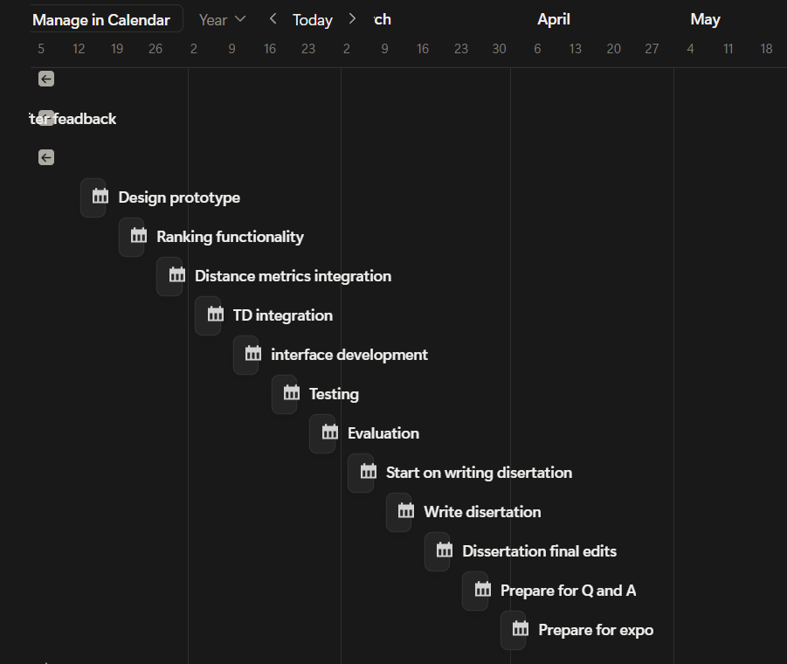
  - Risk Analysis

Here are some possible risks that may occur during the project's development. Also, on the right side of the table, there are according to mitigations.

 | Risks | Likelihood | Impact | Mitigations
1. | Difficulty implementing TD learning. | Medium | High | Ensuring the weight adjustment operations work predictably before integrating user feedback.
2. | Attempting to implement non-essential features before core functionalities are finalized. | High | Medium | Consult the project plan for ensuring that prioritised features are the ones that are being implemented.
3. | Faults in distance logic implementation. | Low | Medium | Testing each distance metric's functionality after implementation.
4. | The ranking operation is too slow for a larger dataset. | Medium | Medium | Identify bottlenecks and prioritize optimization.
5. | Overlapping of the rules. | Low | Medium | Redesign the rules in a way that avoids overlapping.

  - Ples
- Generative AI
No generative AI was used in the making of this report. The only editing assistance that I used in this project was the built-in word processor for spelling mistakes.

A.4 Rules

Here are the predetermined rules for the system.

 | Rule | Explanation | Example
1. | Symmetry | Number sequences that can be read the same from left to right and from right to left. 1 indicates the longest symmetrical sequence and 0 the absence. | 2345432,  12321,  1221
2. | Single-digit repetition | Repeated single or collections of digits in a row. It indicates the times number repeats. 10 indicates all numbers repeating, and 0 indicates no repetition present. | 222,  344566,  455455
3. | Numerical pattern repetition | Repeated numerical patterns such as pairs or triplets. | 233233,  2525
4. | Periodicity | Repeated pattern every few steps. | 75767  780781
5. | Sequences | Number sequences. 1 indicates all the single digits, and 0 indicates the absence of sequences in the phone number. | 5678,  456
6. | Simple keyboard patterns | Combinations of numbers that make simple rows on the keyboard counter. From max 2 patterns to 0. | 123, 456, 789, 741, 852, 963, 159, 753, 357, 951, 8520, 0258.
7. | Unique number count | Unique numbers are present in the phone number. 0 indicates all the unique numbers included in the number, and 1 indicates only one number repeated. | 12322123,  45445444
8. | Chunking | Measures the other pattern appearance in certain segments of the number. | 555-333,  6969-111

A.5 UML activity diagram

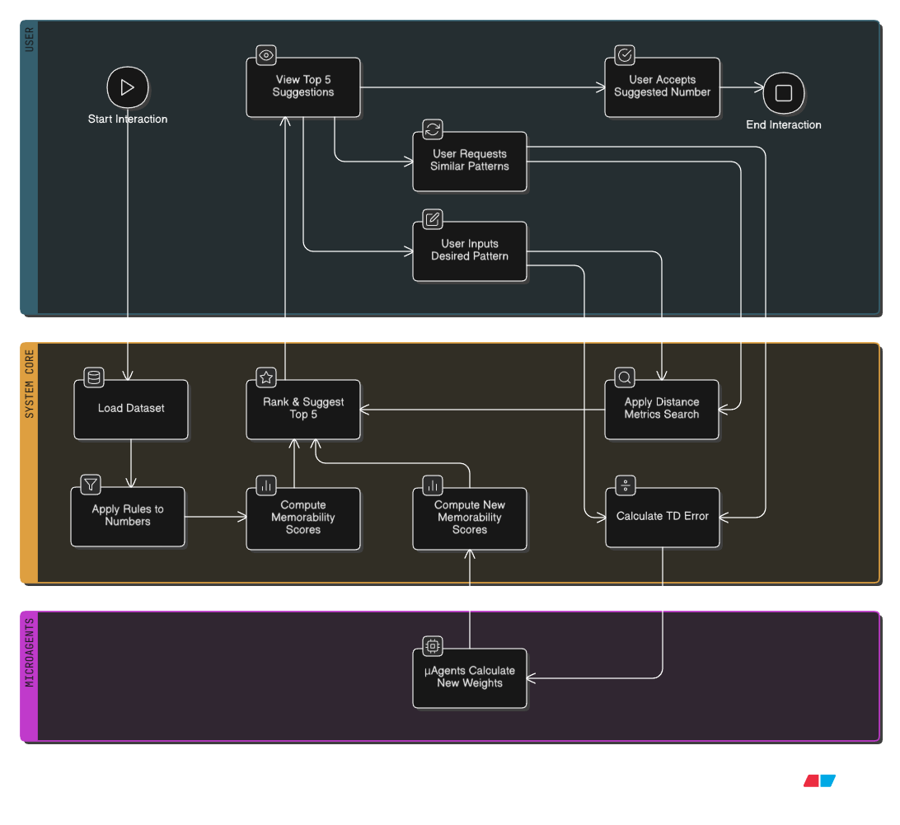

A.7 Project management

For the project management, an Agile approach will be used. It aligns well with the project's modular system design, enabling iterative implementation in short sprints. This type of project management style is flexible and adheres to the need of working with continuous updates, depending on constant feedback. This enables rapid, constant improvements. Each sprint will focus on the development of a singular operation and testing it.

For tracking the progress, and keeping the meeting minutes with the supervisor, Notion is used for this project. The OneDrive folder is set up for keeping back up versions of any documentation, diagrams, or code needed for this project. The GitHub repository set and the access is given to this project supervisor.

